Links to github and LinkedIn post.

STEPS IN CREATING A LAMP STACK PROJECT.

1. Create an EC2 Instance in a cloud environment (AWS, AZURE, GCP)
2. Log in to your EC2 instance and install the Apache server.
3. Install mysqldatabase
4. Install PHP.

I was logging into the ec2-instance. Ensure to enable port 80 and/0r port 443 on your ec2 instance.

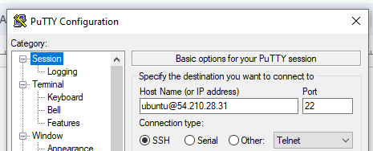

Installing apache on the ec2 instance.

#update a list of packages in package manager

$ sudo apt update

#run apache2 package installation

$ sudo apt install apache2

Log in to your ec2instance public IP to confirm apache is running.

Installing mysl on the ec2 instance.

$ sudo apt install mysql-server

When the installation is finished, log in to the MySQL console by typing:

$ sudo mysql

$ exit

Installing PHP and other dependencies.

$ sudo apt install php libapache2-mod-php php-mysql

php -v (to confirm the installation)

#### Creating a Virtual Host for your Website using Apache

<VirtualHost *:80>

ServerName projectlamp

ServerAlias www.projectlamp

ServerAdmin webmaster@localhost

DocumentRoot /var/www/projectlamp

ErrorLog ${APACHE_LOG_DIR}/error.log

CustomLog ${APACHE_LOG_DIR}/access.log combined

</VirtualHost>

1. Confirming Apache

